LAB 05

5-1)

Multipath Load Balancer:

sudo ovs-ofctl -O OpenFlow13 dump-flows s1

sudo ovs-ofctl -O OpenFlow13 dump-flows s2

sudo ovs-ofctl -O OpenFlow13 dump-flows s3

sudo ovs-ofctl -O OpenFlow13 dump-flows s4

sudo ovs-ofctl -O OpenFlow13 dump-flows s5

sudo ovs-ofctl -O OpenFlow13 dump-group-stats s1

mininet> h2 iperf   -s &

mininet> h1 iperf -c h2 -t 60 -P 5

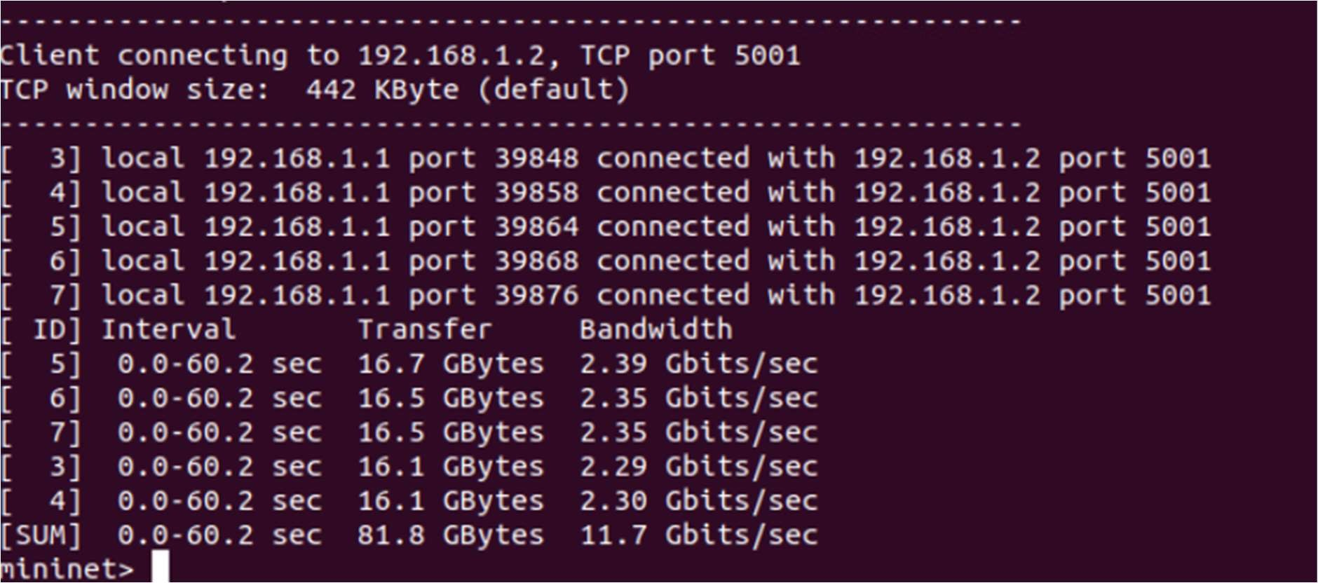

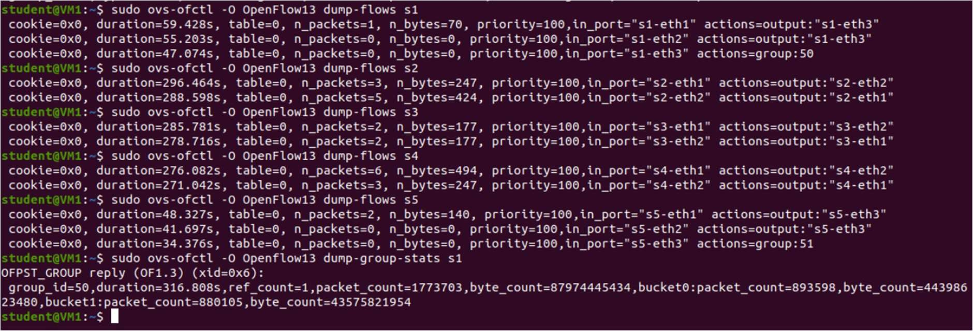

CONTINUE TO NEXT PAGE

5-2)

Meter Table:

mininet> h1 iperf -u -c h2 -b 10m

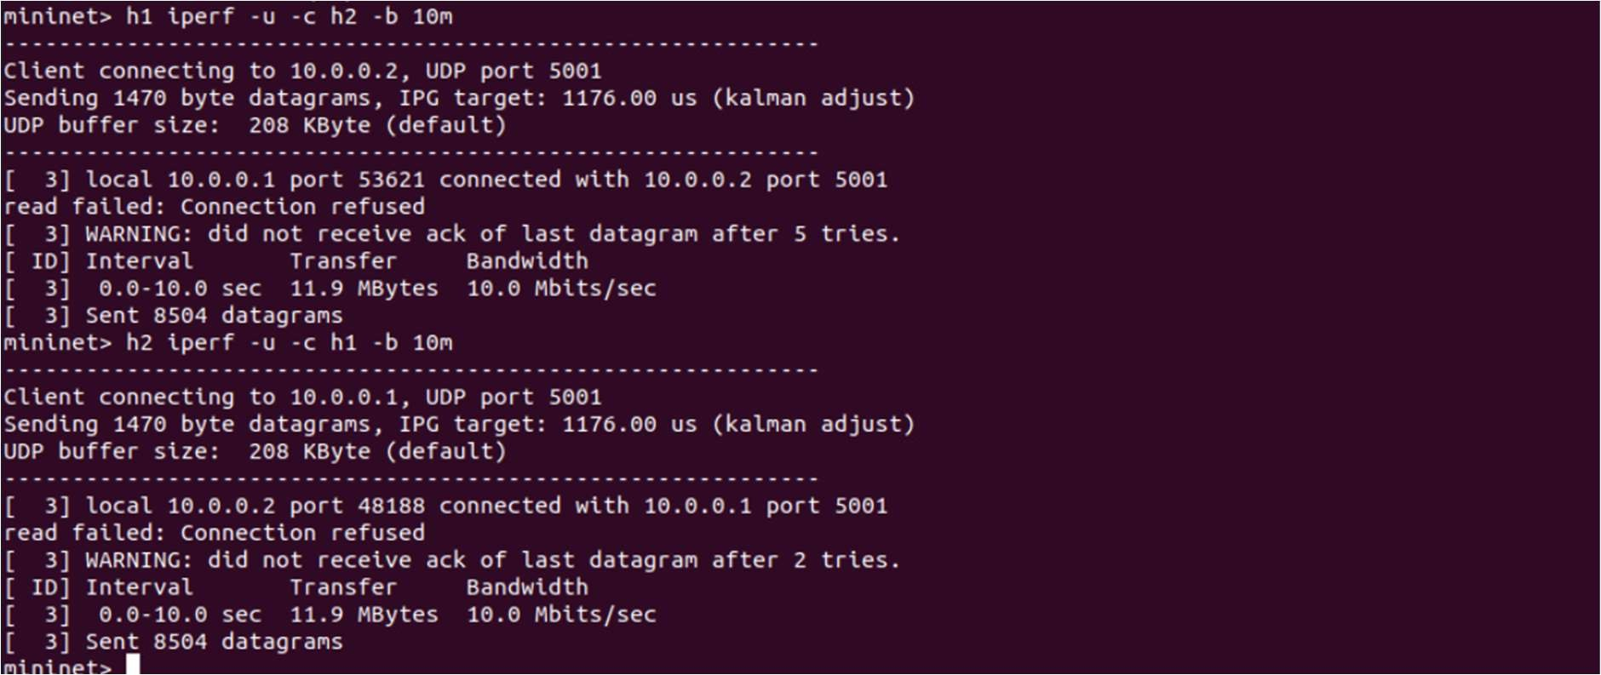

sudo ovs-ofctl -O OpenFlow13 dump-flows s1

sudo ovs-ofctl -O OpenFlow13 dump-meters s1

sudo ovs-ofctl -O OpenFlow13 meter-stats s1

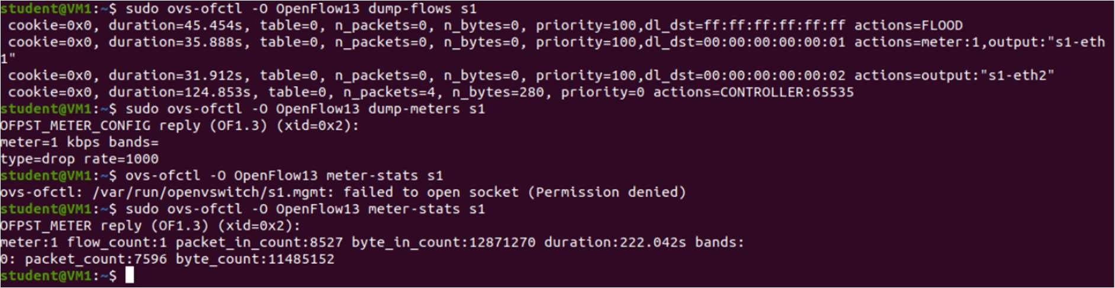

CONTINUE TO NEXT PAGE

FLOW MANAGER:

Packets being dropped for h1 from h3 or h4

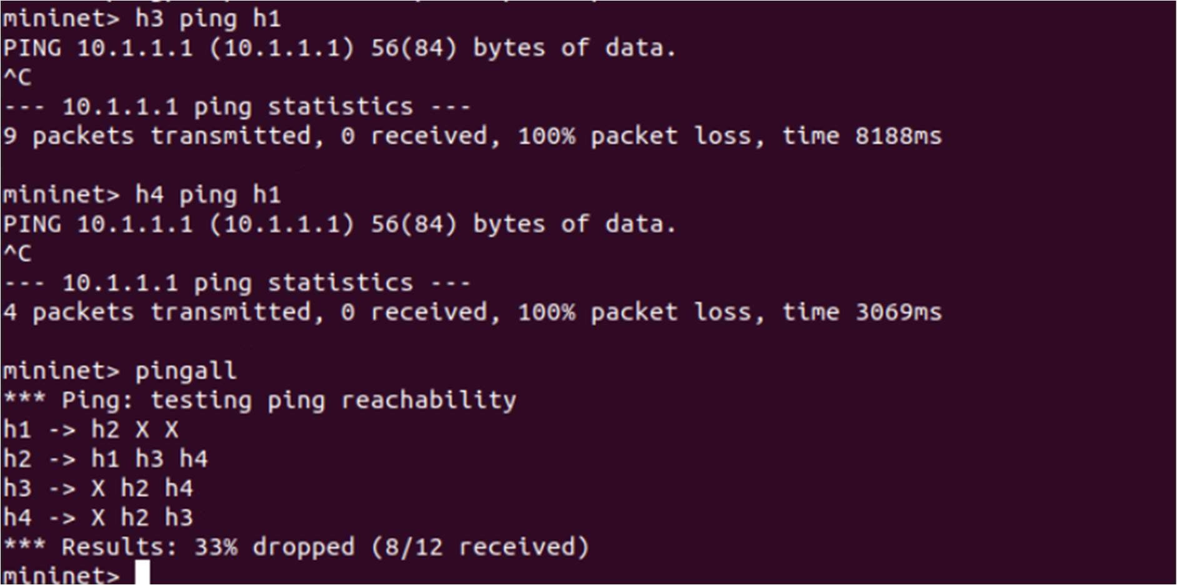

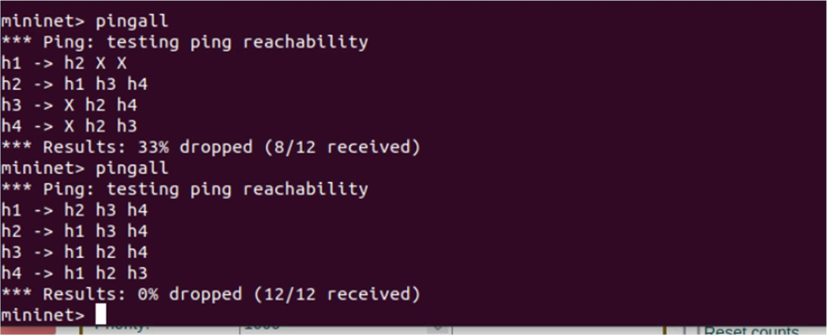After deleting the ﬂow we added before, h1 can ping h3 now

CONTINUE TO NEXT PAGE

Deleting ﬂow with OUTPUT Port number 1-

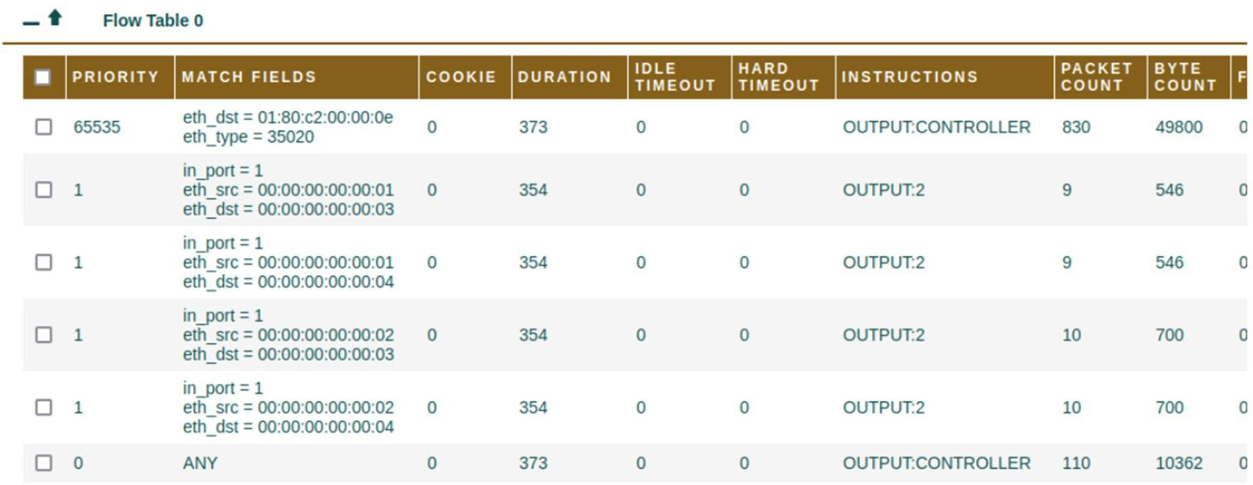

Deleting All Flows-

